

**Date of Submission:** July 26, 2023



**I**



**II**



**III**

CERTIFICATE OF APPROVAL



**IV**

# DEDICATION

I dedicate this work to my loving family, whose unwavering support and encouragement have been the driving force behind my pursuit of knowledge. From the earliest days of my education, they instilled in me a deep passion for learning, making countless sacrifices to ensure I had access to the best possible educational opportunities. Their belief in my potential has been a constant source of inspiration, and I am forever grateful for their guidance and love.

This work is also dedicated to the dedicated teachers at Institute of Information Technology. Their unwavering commitment to education and their belief in their students' abilities have played a pivotal role in shaping my academic journey. Their guidance, encouragement, and mentorship have not only imparted knowledge but also instilled in me the values of perseverance and curiosity. I am indebted to them for fostering an environment of growth and for nurturing my thirst for knowledge.

To my family and my esteemed teachers, this work represents the culmination of years of learning, growth, and dedication. Your support and belief in me have been instrumental in my success, and I am honored to share the fruits of my efforts with you. As I continue to embark on new endeavors, I carry with me the invaluable lessons you have imparted, and I dedicate my future achievements to the legacy of love and support you have provided.

**V**

TABLE OF CONTENTS

**VI**

|  |  |  |  |  |  |  |  |
| --- | --- | --- | --- | --- | --- | --- | --- |
| Letter of Transmittal | | | | | | | I |
| Declaration | | | | | | | II |
| Letter of Endorsement | | | | | | | III |
| Certificate of Approval | | | | | | | IV |
| Dedication | | | | | | | V |
| Table of Contents | | | | | | | VI |
| List of figures | | | | | | | VIII |
| Offer Letter | | | | | | | IX |
| Acknowledgement | | | | | | | X |
| Preface | | | | | | | XI |
| Executive Summary | | | | | | | XII |
|  | | | | | | |  |
| **Chapter One** | | | | | | | |
| **Introduction** | | | | | | |  |
| 1.1 | Preamble | | | | | | 1 |
| 1.2 | Objective | | | | | | 1 |
| 1.3 | Scope | | | | | | 1 |
| **Chapter Two** | | | | | | | |
| **Company Overview** | | | | | | |  |
| 2.1 | Leads Corporation Limited | | | | | | 2 |
| 2.2 | Vision | | | | | | 3 |
| 2.3 | Mission | | | | | | 3 |
| 2.4 | Products | | | | | | 3 |
| 2.5 | Solution | | | | | | 3 |
| 2.6 | Services | | | | | | 4 |
| 42.7 | Client of LEADS | | | | | | 4 |
| 2.8 | Software Development | | | | | | 5 |
| 2.9 | Location and Physical Layout | | | | | | 5 |
| 2.10 | Human Resource | | | | | | 6 |
| 2.11 | Facilities for Employees | | | | | | 6 |
| 2.11.1 | | | | | | Environment | 6 |
| 2.11.2 | | | | | | Lunch and snacks | 7 |
| 2.11.3 | | | | | | Recreation | 7 |
| 2.12 | Offline Schedule | | | | | | 7 |
| 2.13 | Culture of fun and creativity | | | | | | 7 |
| 2.14 | Others | | | | | | 8 |
| **Chapter 3** | | | | | | | |
| **My Project Involvements** | | | | | | |  |
| 3.1 | BankUltimus | | | | | | 10 |
| 3.1.1 | | | | | | Overview of the project | 10 |
| 3.1.2 | | | | | | Team | 10 |
| 3.1.3 | | | | | | Technologies | 10 |
| 3.1.4 | | | | | | Challenges | 11 |
| 3.2 | MIS Team or Report Team | | | | | | 11 |
| 3.2.1 | | | | | Overview of the task | | 11 |
| 3.2.2 | | | | | Team | | 12 |
| 3.2.3 | | | | | Technologies | | 12 |
| 3.2.4 | | | | | About Technologies | | 12 |
| 3.2.5 | | | | | Description of my Team Task | | 13 |
| 3.2.5.1 | | | | | Create report | | 15 |
| 3.2.5.2 | | | | | Create procedure in PL/SQL | | 16 |
| 3.2.5.3 | | | | | Report deployment (test environment) | | 17 |
| 3.2.5.4 | | | | | Schema create in oracle | | 19 |
| 3.2.5.5 | | | | | Live deployment report | | 19 |
| 3.2.5.6 | | | | | On demand services provide | | 19 |
| 3.2.5.7 | | | | Client visits | | | 20 |
| 3.2.5.8 | | | | Attend Seminar or Meeting | | | 20 |
| 3.2.5.9 | | | | Automated Beta Testing | | | 21 |
| 3.2.5.10 | | | | Other Relevant Activities | | | 21 |
| 3.2.6 | | | | Challenges | | | 21 |
| 3.2.6.1 | | | | Identified/Observed in the Organization | | | 21 |
| 3.2.6.2 | | | | Academic Preparation | | | 22 |
| 3.2.6.3 | | | | Personal/Professional Skills | | | 22 |
| **Chapter Four** | | | | | | | |
| **Professional Growth** | | | | | | |  |
| 4.1 Technologies and Tools I Learned | | | | | | | 23 |
| 4.1.1 | | Tools | | | | | 23 |
| 4.2 Technology | | | | | | | 23 |
| 4.2.1 | | | JavaScript Frameworks | | | | 23 |
| 4.2.2 | | | Oracle database | | | | 23 |
| 4.2.3 | | | Development Technique | | | | 23 |
| 4.3 Professional Learning | | | | | | | 24 |
| 4.3.1 | | | No bullying and blaming | | | | 24 |
| 4.3.2 | | | Complete task properly | | | | 24 |
| 4.3.3 | | | Adaptability | | | | 24 |
| 4.3.4 | | | Punctuality | | | | 24 |
| 4.3.5 | | | Self-confidence and Teamwork | | | | 24 |
| 4.4 Self-Assessment | | | | | | | 24 |
| 4.4.1 | | | Problem-Solving | | | | 24 |
| 4.4.2 | | | Punctuality | | | | 25 |
| 4.4.3 | | | Adaptability | | | | 25 |
| 4.4.4 | | | Quality of work | | | | 25 |
| 4.4.5 | | | Overall Performance | | | | 25 |
| **Chapter Five** | | | | | | | |
| **Conclusion** | | | | | | | 27 |
| **Reference** | | | | | | | 28 |
| **Appendix** | | | | | | | 29 |
| **Elaboration** | | | | | | | 29 |

**VII**

LIST OF FIGURES

|  |  |
| --- | --- |
| Figure 1: Logo of Leads Corporation Limited | 2 |
| Figure 2: Some Clients | 5 |
| Figure 3: Office building of Leads Corporation Limited | 6 |
| Figure 4: Lunch party | 7 |
| Figure 5: Collected Gift from Management community | 8 |
| Figure 6: Attended Cultural program | 8 |
| Figure 7: MIS Team Member | 9 |
| Figure 8: BankUltimus Team Member | 9 |
| Figure 9: Login Details | 13 |
| Figure 10: Client UI | 15 |
| Figure 11: Required field | 15 |
| Figure 12: Credentials | 15 |
| Figure 13: Report | 15 |
| Figure 14: Crystal Report | 16 |
| Figure 15: PL/SQL Procedure | 17 |
| Figure 16: Databse Table 1 | 17 |
| Figure 17: Database Table 2 | 18 |
| Figure 18: Database Table 3 | 18 |
| Figure 19: Database Table 4 | 19 |
| Figure 20: Client Anydesk | 20 |
| Figure 21: PKB bank | 20 |
| Figure 22: Self-Assessment | 26 |

**VIII**

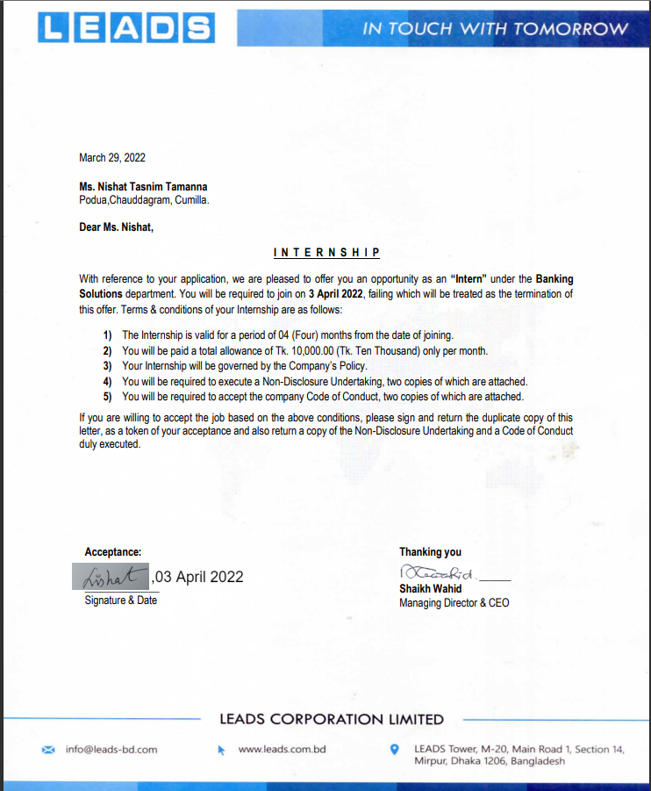

**IX**

OFFER LETTER

I, Nishat Tasnim Tamanna, here I would like to say that I have successfully completed my internship at LEADS Corporation Limited in the Department of Banking Solution from April 3 to September 30. This internship was a valuable learning experience and an opportunity for me to apply the knowledge and skills gained during my academic pursuits.

First of all, I would like to express my heartfelt gratitude to my respected chairman of internship examination committee Md. Iftekharul Alam Efat for continuous guidance and support through the whole procedure of the intern and motivated me to accomplish the research in the field of internship.

Throughout the internship period, I actively participated in various tasks and projects, gaining insights into the functioning of LEADS Corporation Limited and the industry as a whole. I would like to express my heartfelt gratitude to my mentor, Uzzal Koiri, for their guidance, support, and encouragement during this journey. Their expertise and constructive feedback played a significant role in shaping my understanding of the field and sharpening my professional acumen.

In conclusion, I am deeply grateful for giving the opportunity to intern my honorable teacher, my own Institute, Institute of Information Technology, Noakhali Science and Technology University. This internship has not only broadened my horizons but also reinforced my passion for pursuing a career in IT sector field.

**X**

ACKNOWLEDGEMENT

# PREFACE

This document contains the internship period I had from April 3 2022- September 30, 2022 at LEADS Corporation Limited as a Jr. Software Engineer Intern. This document contains five chapters that explain different aspects of experience I got through the internship period. Therefore, this contains basic information internship establishment and descriptive information on the internship I got and my opinions on the overall internship period considering the whole experience.

The initial chapter contains basic introduction of internship like preamble, objective and scope, The second chapter contains information of company or company profile, company overview. In this chapter I represent company address, mission and vision, also describe all others policies.

The third chapter contains My Project Involvements. This is the main chapter describe all about during my internship periods. The fourth chapter contains Professional Growth of myself after completing my internship. In fifth chapter contain conclusion and finally Reference and Appendix.

**XI**

# EXECUTIVE SUMMARY

This executive summary presents an overview of my internship experience at LEADS Corporation Limited. The internship spanned from April 3 to September 30.

I had the privilege of working with a team of talented professionals who nurtured my growth and encouraged me to push my boundaries.

Throughout the internship, I actively engaged in diverse projects. These projects exposed me to various aspects of the Banking sector, as well as IT sector. allowing me to apply the theoretical knowledge gained during my academic pursuits. I am proud to have contributed which showcased my ability to work effectively in a team and deliver results.

Under the mentorship of Uzzal Koiri, I flourished both professionally and personally. Their guidance and unwavering support enabled me to tackle complex challenges with confidence and provided me with insights into the industry's best practices. I am grateful for the constructive feedback they provided, which played a significant role in refining my skills and elevating the quality of my work.

**XII**

# 

# 

# ***Chapter 1***

# ***Introduction***

## 1.1 Preamble

An internship is an excellent way for students to create a network and further develop their skills. It provides a period of time to exercise the knowledge they have already gathered from their academic syllabus and get acquainted with industry practices. Sometimes it works as a bridge, creating a connection between academic study and the industry.

As a student of IIT (Institute of Information Technology) at Noakhali Science and Technology University, this glorious opportunity allows students to have an internship within their bachelor's program in the 7th semester. The six-month internship program is possibly the most effective way of achieving industry orientation.

For applying to any kind of job, practical knowledge is crucial. I have successfully completed my internship at Leads Corporation Limited, one of the leading software companies in Bangladesh.

## 1.2 Objective

This report has been prepared as a requirement of the internship program for the degree BSSE. I joined Leads on April 3, 2022, and my role was Jr. Software Engineer Intern. I was assigned to two teams: the development team and the MIS (Management Information Systems) team or report team.

This report represents my achievements, project involvements, professional growth, leadership skills, interpersonal communication growth, how to handle clients, providing services to clients, clients visited, and other experiences during the internship period at Leads Corporation Limited.

## 1.3 Scope

This report elaborates on the overall experience I gained through the internship program and the challenges I faced in my workplace at Leads Corporation Limited. The process of working in a team and the structure of team management are added in this report. It also highlights how I adapted to the industrial environment and its technical tools. It mainly focuses on banking software, the real-life projects I was involved in, and the various tools and technologies I used. The report concludes by elaborating on my technical and professional growth after experiencing the internship program.

**1**

# ***Chapter 2***

# ***Company Overview***

## 2.1 Leads Corporation Limited

LEADS is involved in designing, developing, implementing, and maintaining business application software for both domestic and overseas markets. LEADS provides Core Banking Solution (BankUltimus) for the banking industry for both local and global markets. In addition to the banking industry, LEADS provides products, services, and solutions for non-banking financial companies, agent banking, capital markets, broker houses, life insurance, enterprise resource planning (ERP), etc.

Furthermore, LEADS provides a complete life cycle of software development services, including system analysis, use case development, system architecture & design, system integration, native and web API development, UI/UX design, database design and administration, functional and system testing, quality assurance, and project management. Apart from the above-mentioned services, LEADS also provides diversified IT solutions and services that support the attainment of clients’ business objectives, such as building network infrastructure, plastic card personalization, delivery & installation of PCs, servers, storage, and backup solutions, POS, and ATMs, etc.

Over the last couple of years, LEADS has also moved into disruptive technologies like BLOCKCHAIN, Internet of Things (IoT), Artificial Intelligence (AI), etc. Today, LEADS is considered one of the renowned ICT Solution Providers of Bangladesh and has become the IT partner of choice for managing people, processes, and environments. Continuous thrust for improving quality is the reason behind its success. From a paltry 12 individuals, which LEADS inherited in 1992, it now has a core competent team of 300 personnel.



Figure 1: Logo of Leads Corporation Limited

**2**

## 2.2 Vision

To understand customers’ business and technology issues and deliver measurable, tangible results through our experience in and commitment to a varied range of platforms and products, we are dedicated to staying current with reliable and proven technologies. This enables us to maximize the value of our services to our customers and develop a competent and highly motivated workforce.

## 2.3 Mission

To be a model of excellence as an Information & Communication Technology company that our Shareholders, Customers, Suppliers, Associates, and Society would love to be associated with.

## 2.4 Products

Leads Provides some product, Like

* Banking products like Core Banking Solution (CBS)
* NBFI(Non-banking financial institution ) solutions
* Insurance solutions
* Capital Market solutions
* ERP(Extended Producer Responsibility)
* Data Analysis
* Digital Innovation

## 2.5 Solutions

Leads Corporation limited provided some solution for solving banking and others problem.

* Cash Management Solution
* Card personalized Solution
* Online Real-time CDM
* Entrust solution
* Government Solution
* Security Solution

**3**

## 2.6 Services

In today’s world, every organization depends heavily on technology to keep business operations connected, drive revenue and support ever growing customer demands. Many of the services are provided by Leads Corporation Limited. Some list are given below

* IT services
* Visual Office
* Training
* Consultancy
* Managed services
* Application Development
* Recourse Outstanding

## 2.7 Clients of LEADS

* Uttara Bank Limited
* UFL(United Finance Limited)
* BFFIL(Bangladesh Infrastructure Finance Fund Limited)
* PKB (Probasi Kollan Bank)
* SFIL(Strategic Finance & Investments Limited (SFIL)
* First Security Islami Bank
* Meghna Bank
* Standard Bank
* Southeast Bank
* Premier Bank
* National Bank of Pakistan
* Modhumoti Bank

**4**



 

Figure 2: Some Clients

## 2.8 Software Development

Leads Corporation Limited teams help the customers build custom software - everything from web to desktop, enterprise to mobile, and beyond. Leads have worked with numerous technology platforms and collaborated with many teams over the years. Its clients get a team of their own – it is as simple as that. There is no red tape – the team adapts to the working process of the client and is there as one of their own.

## 2.9 Location and Physical Layout

Location Of the Leads Tower LEADS Tower, M-20,  
Main Road 1, Section 14, Mirpur,  
Dhaka 1206, Bangladesh

[engage@leads.com.bd](mailto:engage@leads.com.bd), Phone: [(+880) 241 001 205](tel:+880241001205)

**5**

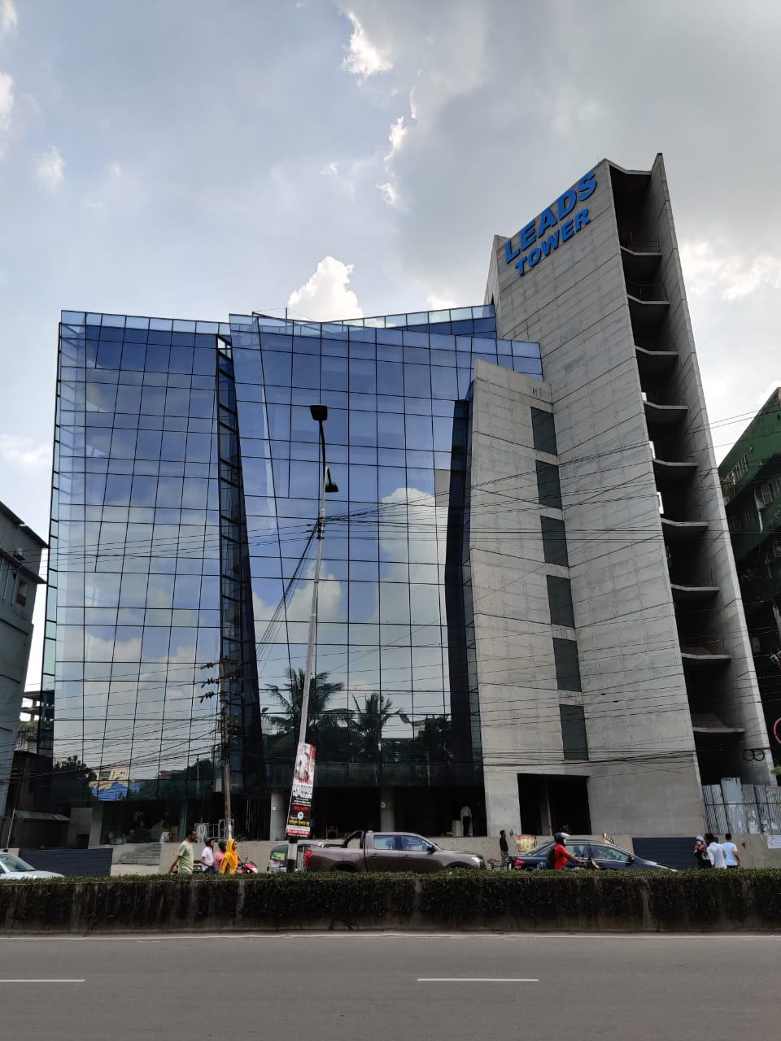

Figure 3: Office building of Leads Corporation Limited

Leads office is situated in a residential area rather than an industrial area, so the employees work in a domestic environment. The first two floors of the building are used for operating the office, while the 5th to 7th floors is occupied by the office. The 7th floor contains the HR department, the Managing Director's room, and other members of the management team. A prayer room is also available in the Leads Building.

## 2.10 Human Resource

Leads has 300+ employees at this moment and they are planning to recruit more. Leads has 32 years’ experience, beside of this lead has grown in number of resources and production every year it hires only the best. Leads has 15+ partners and 500+ customer.

## 2.11 Facilities for Employees

According to two factor theory of job satisfaction, salary is just a hygiene factor. Motivation factors are important for high productivity. Leads Corporation Limited provides several facilities for the employees except salary.

### 2.11.1 Environment

Leads provides a very friendly and flexible work environment. Female employees have many opportunities and can easily work from their office online. Female employees don't need to go to the client site for any support or live issues.

**6**

### 2.11.2 Lunch and snacks

Leads provides its employees with unlimited tea or coffee and occasionally arranges evening snacks or, on certain occasions, lunch. However, lunch and snacks are not provided every day. Here are some pictures of the lunches we have had.

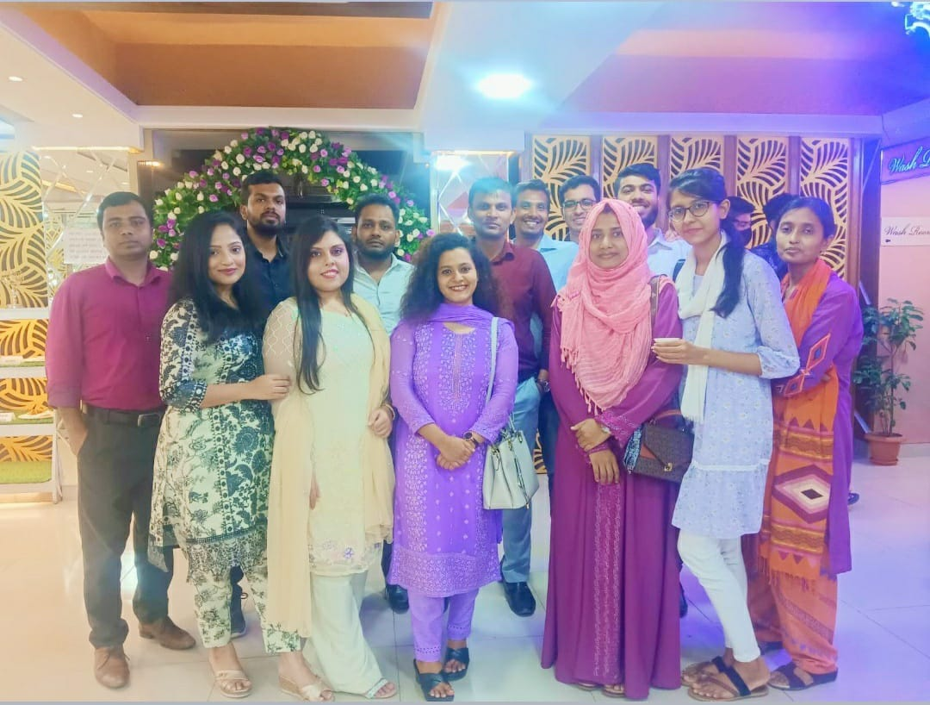

Figure 4: Lunch party

### 2.11.3 Recreation

Leads has different ways for recreation of employee. Release parties, picnics, sudden party’, outings are part of it. Employees are taken out of the country for anniversary of leads every year. I am sure these are only a small fraction of the facilities available at leads corporation limited. In spite of being an intern, I received all these facilities and consider myself lucky.

## 2.12 Office Schedule

The office operates from 9 am to 5 pm. Leads provides its employees with a 1-hour flexible time window within this period. However, the standard office hours are from 9 am to 5 pm. Occasionally, employees may face some issues with their existing software, such as BankUltimus then, which may lead to an automatic extension of office hours by 1 or 2 hours. Additionally, Leads provides a 1.30-minute lunch break and offers prayer time twice a day.

## 2.13 Culture of fun and creativity

Leads arrange some cultural program like family day of leads. In this day leads provided cactus and chocolate to children. Beside of these type of program leads arranges some program like leads provided us water mag to improve awareness of covid19. In the Family Day cultural program, I attend the cultural activities.

**7**

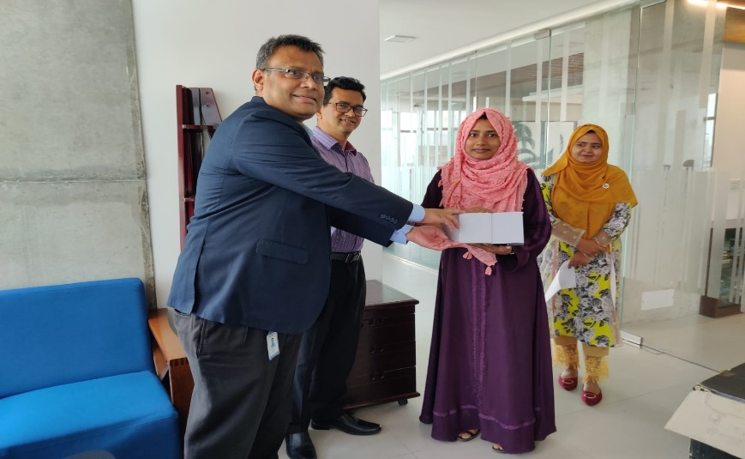

Figure 5: Collected Gift from Management community

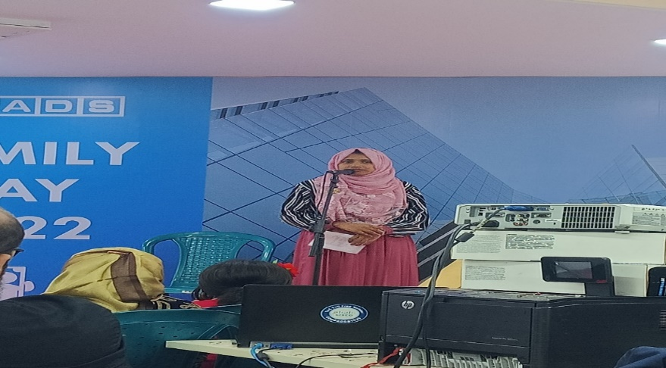

Figure 6: Attended Cultural program

## 2.14 Others

Leads' working environment is very helpful, and professional communication is very strong. When a group of freshers is recruited at Leads, they throw a party for everyone. Being an intern, I was not treated as a fresher. When, I was in the MIS team, and my team members were very helpful. Some of my team members are showed in this pictures.

**8**

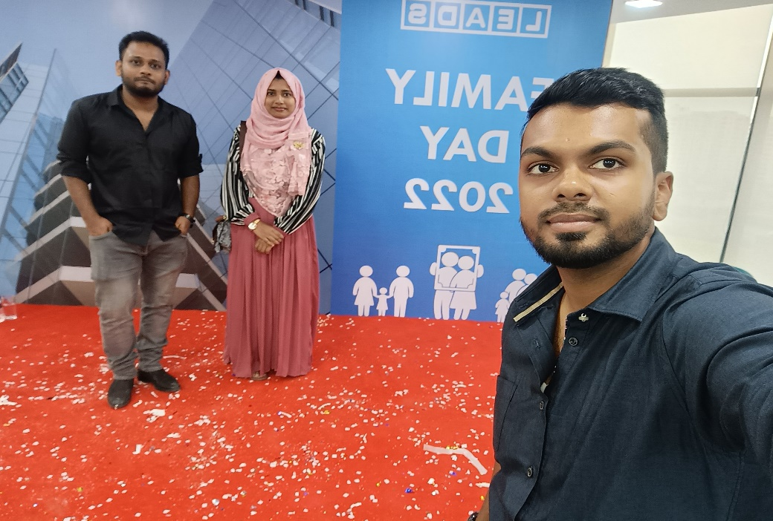

Figure 7: MIS Team Member

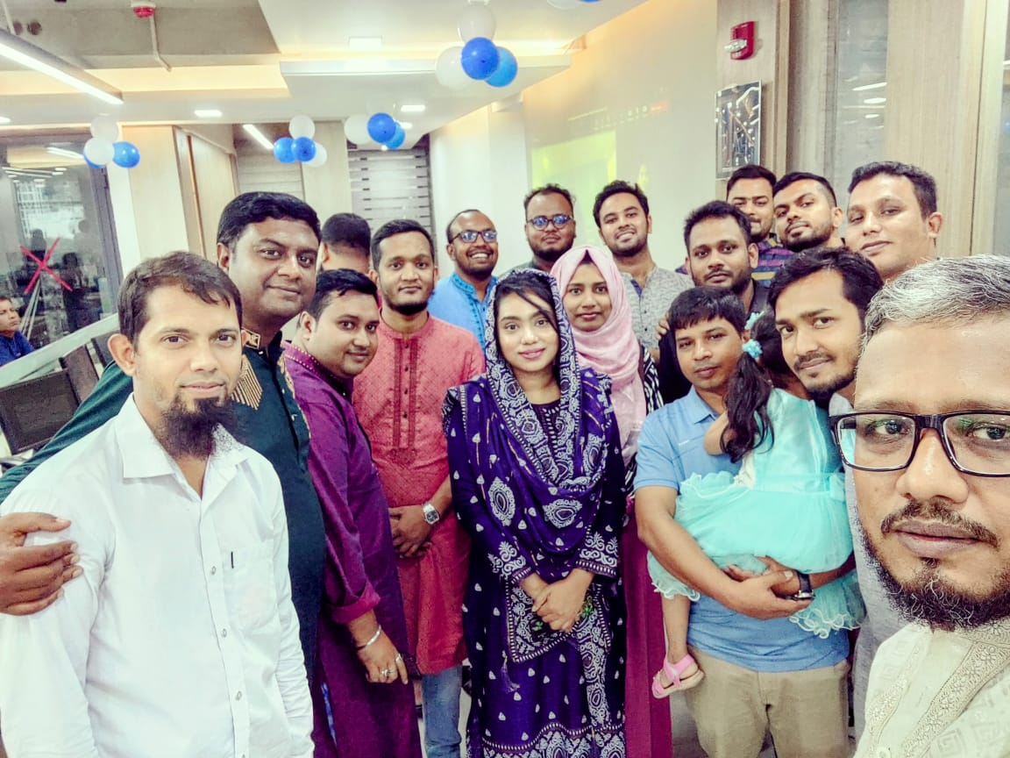

Figure 8: BankUltimus Team Member

**9**

# 

# ***Chapter 3***

# ***My Project Involvement***

## 3.1 BankUltimus

Core Banking Solution (CBS) branded as “BankUltimus” provides integrated solutions for Retail, SME and Corporate banking as well as has features supporting Trade Finance, Loan management system and many more. It is an enterprise banking solution that enables Banks to provide full range of banking services and content to Customer Information File (CIF), Know Your Customer (KYC) & Transaction Profile (TP) according to Central Bank compliance efficiently and reliably.

“BankUltimus” meets the market’s present & future demands. With the help of BankUltimus, transformation to Core Banking today is faster than ever. Technologies like Blockchain, Artificial Intelligence (AI), Mobility (Mobile App) and Data Analytics are evolving rapidly and this is disrupting the prevalent business models of Banks. Starting from Teller Operation to Treasury all areas are attended in detail in BankUltimus.

### 3.1.1 Overview of the project

BankUltimusNext is one of the new versions of BankUltimus Software. After joining as an intern, I was assigned to the development team and started learning web development-related skills. Leads development team provided us with a test project, including requirement collection and designing. My team members provided instructions, and I followed them diligently. I created some basic pages, such as customer profile creation, address information page, and others related to the project. Whenever I encountered any challenges in my test project, I sought help from other team members, and both Najia apu and Shafique vaia were incredibly supportive. With their guidance and assistance, I successfully completed my test project.

### 3.1.2 Team

I was assigned to the development team, and my supervisor was Noor Hossain (Manager of the Development team) for the project. Najia (Sr. Software Engineer) Apu, and Shafique Vaia also helped us during the learning stage. He gave me instructions so that I could understand the project in a short time and also assigned me the bugs to be fixed. Without his helpful mentoring, I could not have been involved with the project successfully.

### 3.1.3 Technologies

When I was assigned to the development team, Najia Apu (Sr. Software Engineer), Shafique Vaia(Sr. Software Engineer), and other team members introduced me to some technologies. They provided me with a list of technologies, and I learned them. Besides that, they also provided me **9**with some resources to learn these technologies. The list of technologies I have already learned from this project includes

**10**

* Vue js
* Vuetify
* JavaScript
* Oracle Database
* Banking domain

### 3.1.4 Challenges

My assigned project name was BankUltimusNext, BankUltimusNext is a new version of the existing banking software, BankUltimus. The project involved developing a complete banking software, but I did not have proper knowledge about the banking domain, making it a big challenge to introduce banking terms used in the project, such as KYC (Know Your Customer) and LC (Letter of Credit), etc. Additionally, the testing phase of the project utilized Vue.js, a framework of JavaScript, and Vuetify, a UI library of Vue.js. These technologies were completely new to me.

## 3.2 MIS Team or Report Team

MIS (Management Information System) is also known as the Report Team. This team is responsible for creating all the banking reports for various banking domains, such as GB (General Banking) reports, TFN (Trade Finance) reports, Loan reports, etc. I joined the MIS team after 20 days of starting my employment at Leads Corporation Limited. At Leads, I worked as a Jr. Software Engineer in the Banking Solution Department and was assigned to the Report Team. My primary responsibility was to create banking reports using Crystal Reports software and Pl/SQL in the Oracle database. The report creation process depended on the bank's specific requirements or whenever Bangladesh Bank made changes to their rules and regulations.

### 3.2.1 Overview of the task

I worked in leads as a Jr. Software Engineer in Banking Solution Department, assigned to the Report team. My responsibility was to Create the Baking report using Crystal Reports software and Pl/SQL in the oracle database. Report creation depends on bank requirements or when Bangladesh Bank makes some changes in their rules and regulations.

**11**

When I was in report team my first task was learn banking domain term like statement of affairs, tax, excise duty, debit, credit loan team, mortgage, general banking, Trade finance etc. My assigned task was

* Beta testing of report
* Create Report
* Create procedure in PL/SQL
* Report deployment (test environment)
* Schema create in oracle for citizen’s bank
* Live report deployment
* On demand service provided to bank or others clients
* Client visit
* Attend meeting or seminar

### 3.2.2 Team

I worked with an amazing team under the Banking Solution department where everyone was dedicated to providing the clients with the best service and satisfying their demands properly. I gained experience through communicating with the clients and observing demonstrations in person.

I was assigned to the MIS team, which has a total of 9 members, including our supervisor, Uzaal Koiri Dada. My other team members are Sohel Rana, Md. Masud, Md. Asad, MST Sadia Sultana, Joytee Shaha, Mafizul Haque, and Noor. My teammates were very helpful and provided us with full guidance to adapt to the team's tasks and easily learn new technologies and banking domains. They were very punctual and friendly.

### 3.2.3 Technologies

When I was in report team I learned these technologies like:

* PL/SQL
* Crystal software
* Selenium

### 3.2.4 About Technologies

* PL/SQL stands for Procedural Language extensions to Structured Query Language. It is a highly structured and readable language.

**12**

* Crystal Reports software is a popular tool that allows developers to create reports and dashboards from a variety of data sources with a minimum amount of code to write.
* Selenium is used for automating beta testing.

### 3.2.5 Description of my Team Task

* The MIS (Management Information System) team plays a crucial role in a software firm. Their primary responsibility is to manage and support the various information systems used within the organization. Here are some key roles and functions of the MIS team in a software firm:
* System Administration: The MIS team is responsible for the administration and maintenance of the company's information systems. This includes managing user accounts, access control, data backups, and system security.

Figure 9: Login Details

* Software Implementation and Integration: The MIS team is involved in the implementation of new software applications and the integration of various systems to ensure smooth data flow and communication between different departments.
* Database Management: They manage the company's databases, ensuring data integrity, security, and optimal performance. This involves designing and maintaining databases, writing queries, and managing data backups and recovery.
* 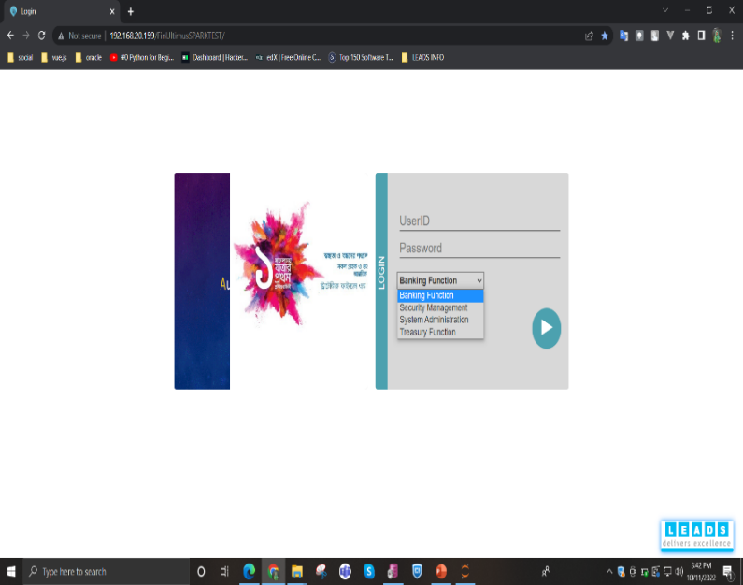Report Generation: The MIS team creates and generates various reports and analytics based on the data collected from different systems. These reports provide valuable insights for decision-making and business analysis.
* User Support and Training: They provide technical support and assistance to users across the organization. This includes troubleshooting software issues, answering queries, and conducting training sessions to help employees make the most of the software tools available.

**13**

* Technology Evaluation: The MIS team is involved in evaluating new technologies, software, and tools that could enhance the company's operations and improve efficiency.
* Security and Compliance: They ensure that the company's information systems comply with relevant data security and privacy regulations. This involves implementing security measures and conducting regular audits.
* System Upgrades and Maintenance: The MIS team is responsible for upgrading software and hardware components to keep the systems up-to-date and running smoothly.
* Overall, the MIS team plays a pivotal role in ensuring the smooth functioning of information systems, supporting the organization's operations, and leveraging technology to enhance productivity and efficiency in a software firm.3.2.5.1 Beta testing

At first, we provided the Fast Path number, such as 9801 (representing the report named 'tax certificates). Then, we entered the required fields using valid data from the database, such as account numbers, transaction dates (from and to), and other necessary information. After filling in these required fields, we checked whether the report was displayed successfully. If the report appeared correctly, we examined the data to ensure its accuracy. This process, known as report beta testing, involved maintaining an Excel sheet to track which reports were functioning correctly and which ones had issues.

When any bank or NBFI (Non-Banking Financial Institution) went live with the system, we thoroughly checked all the reports to ensure they displayed correctly. If we encountered any issues with a report, we communicated with our seniors, and they assisted in resolving the problems. If the issue was minor, I would take the initiative to resolve it myself.

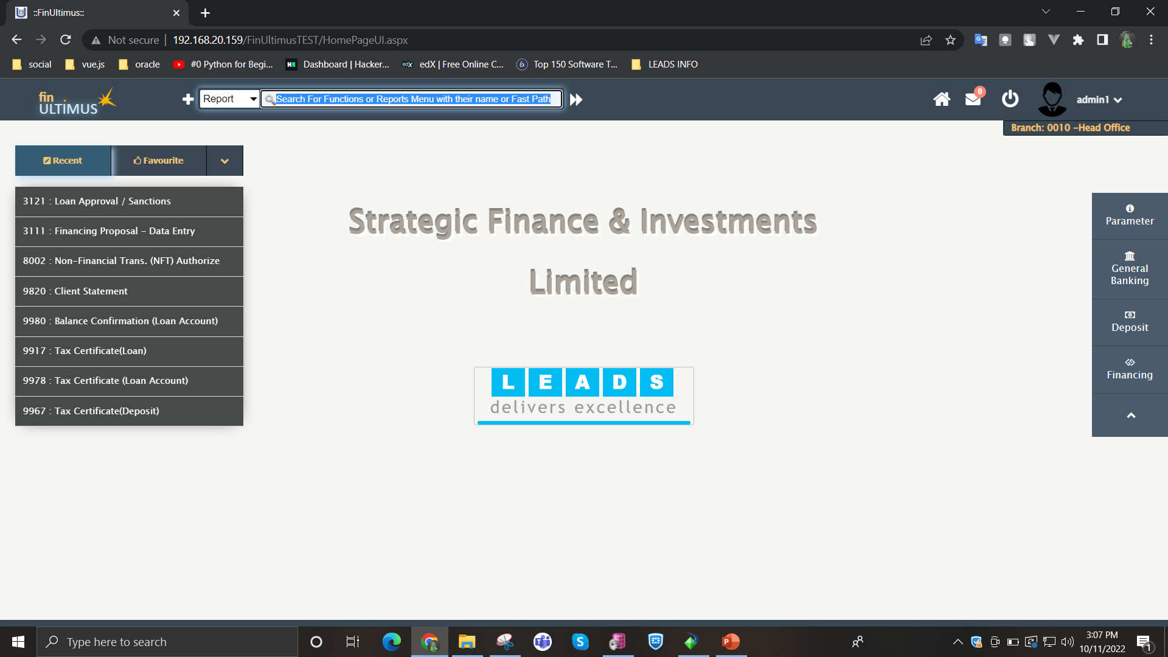

**14**

Figure 10: Client UI

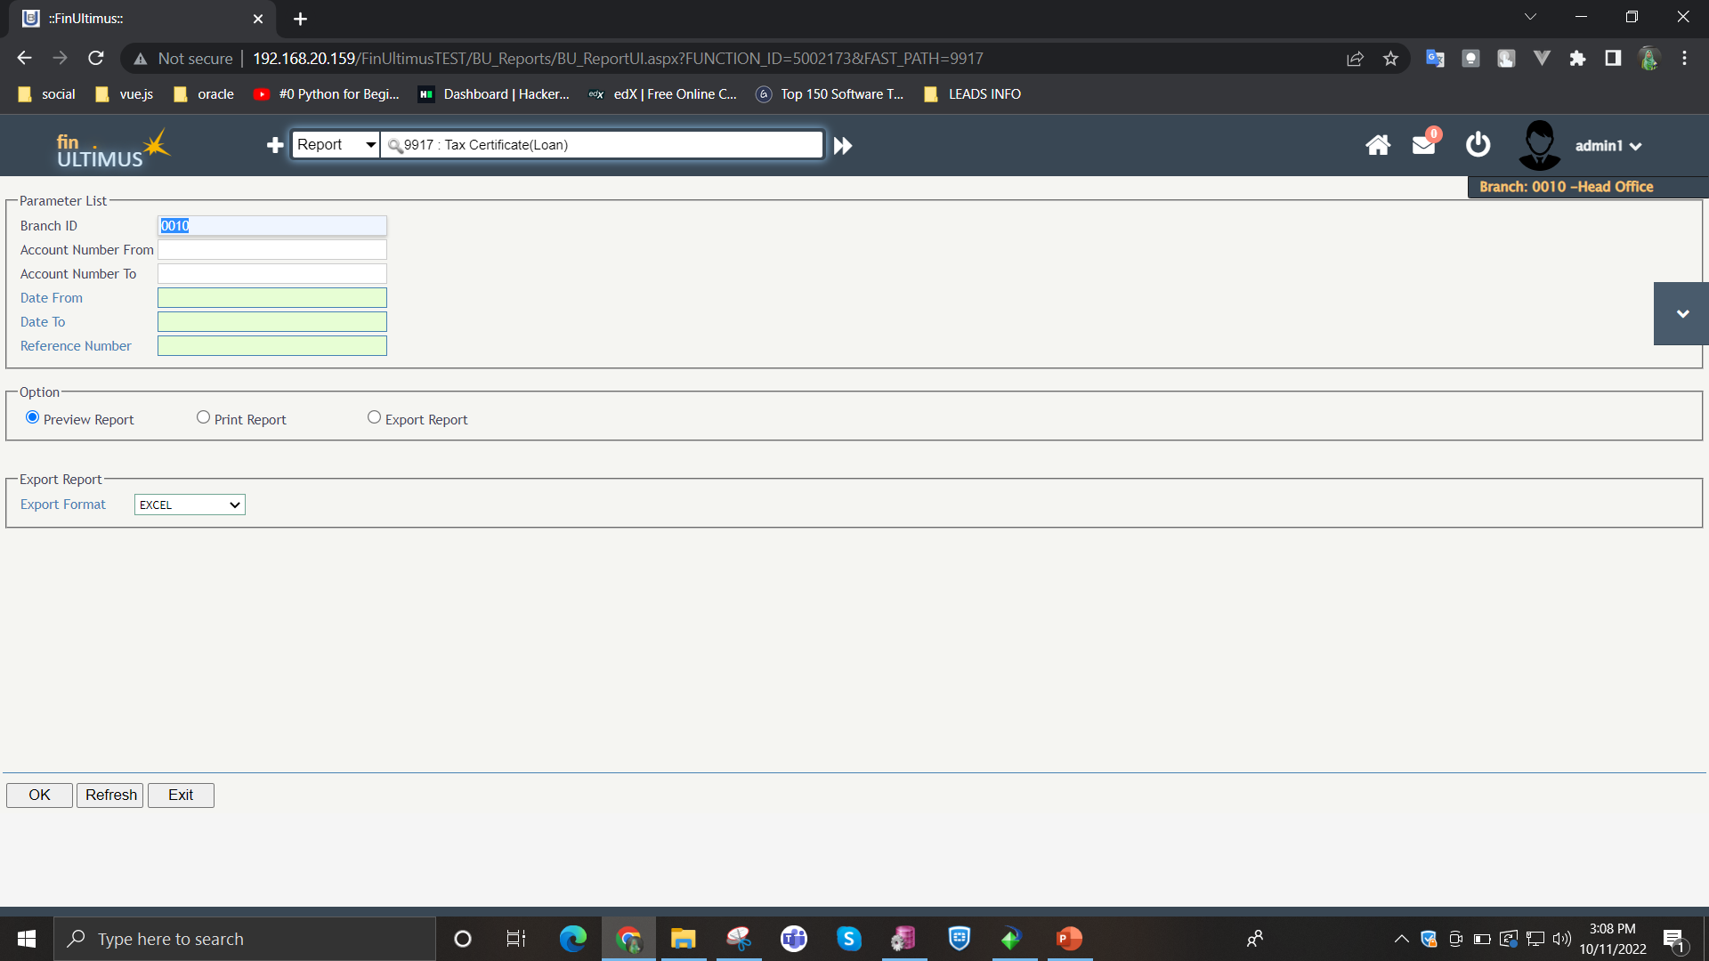

Figure 11: Required field

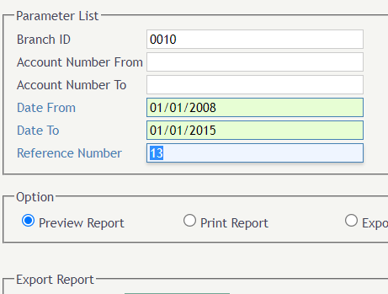

Figure 12: Credentials

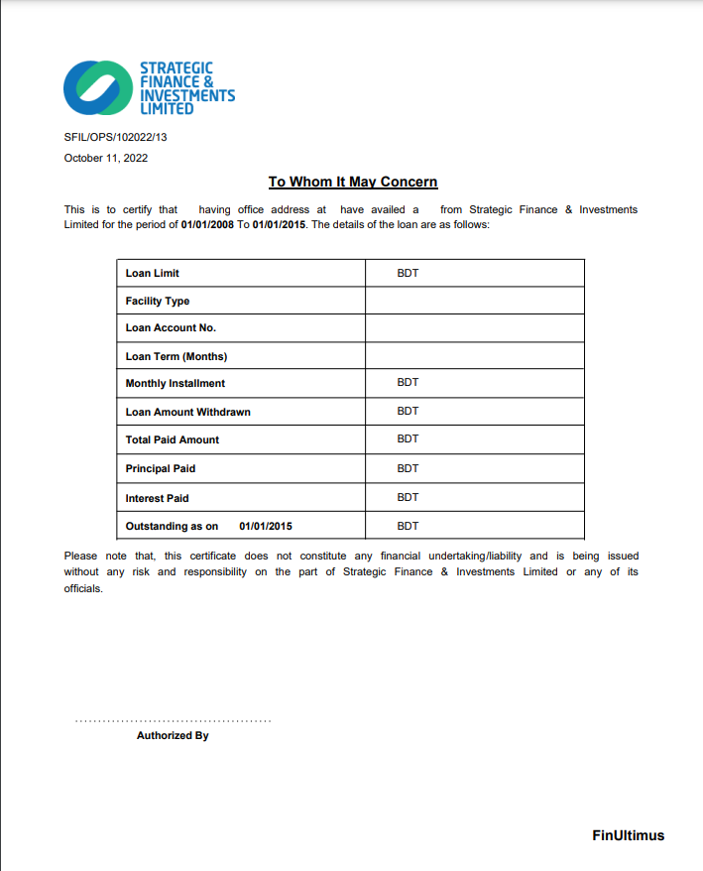

Figure 13: Report

### 3.2.5.1 Create report

**15**

After connected with Oracle database I created report in crystal report software.

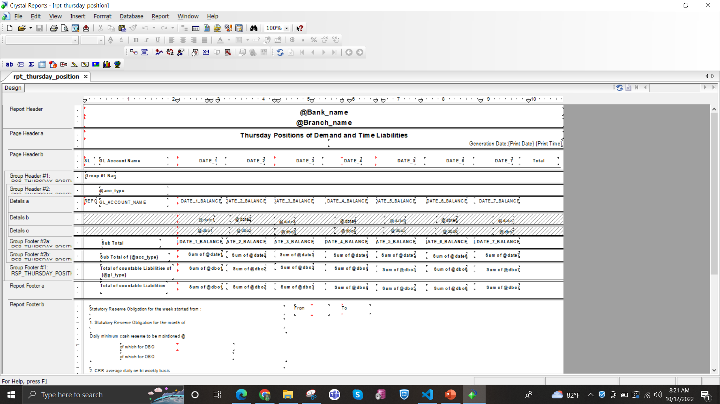

Figure 14: Crystal Report

### 3.2.5.2 Create procedure in PL/SQL

After logged into database then I created some procedure that called storage procedure in PL/SQL.

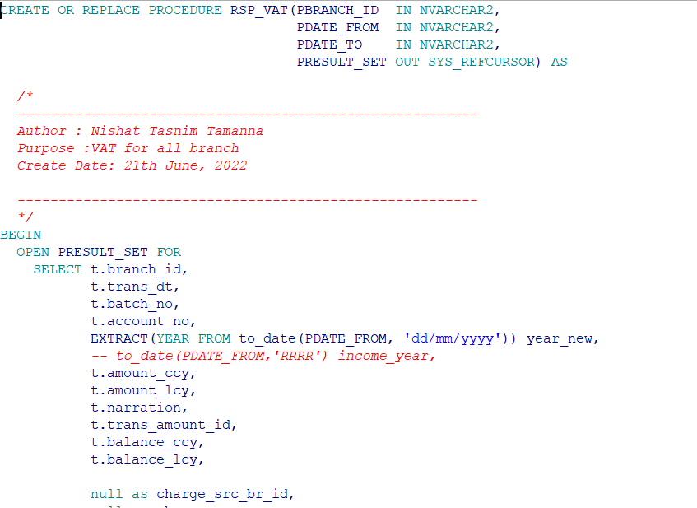

**16**

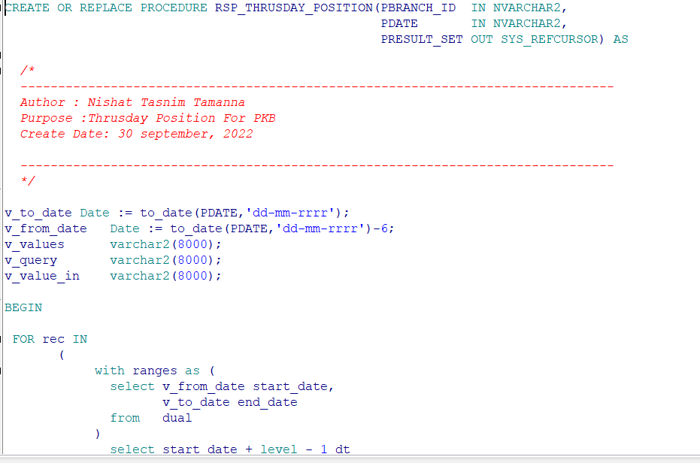

Figure 15: PL/SQL Procedure

### 3.2.5.3 Report deployment (test environment)

After completing the procedure and creating the Crystal Report in the software, I worked in the Oracle database again. In the Oracle database, I inserted data into 4 tables for deployment purposes in the UI.

* Sys_app_function
* Rpt_config_mast
* Rpt_config_param
* Sec_user_role_fun

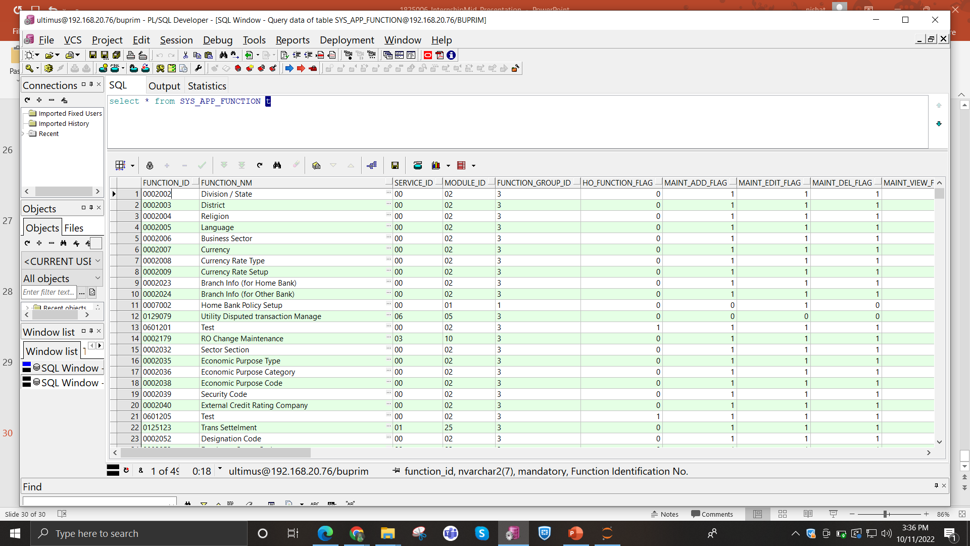

**17**

Figure 16: Databse Table 1

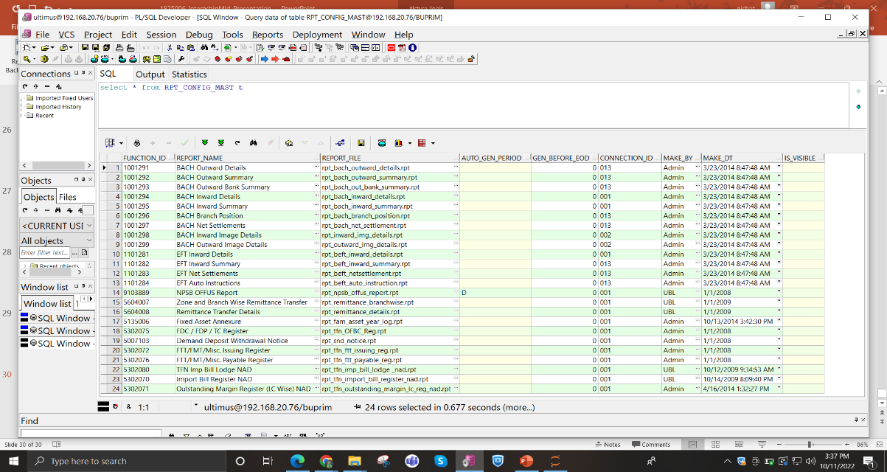

Figure 17: Database Table 2

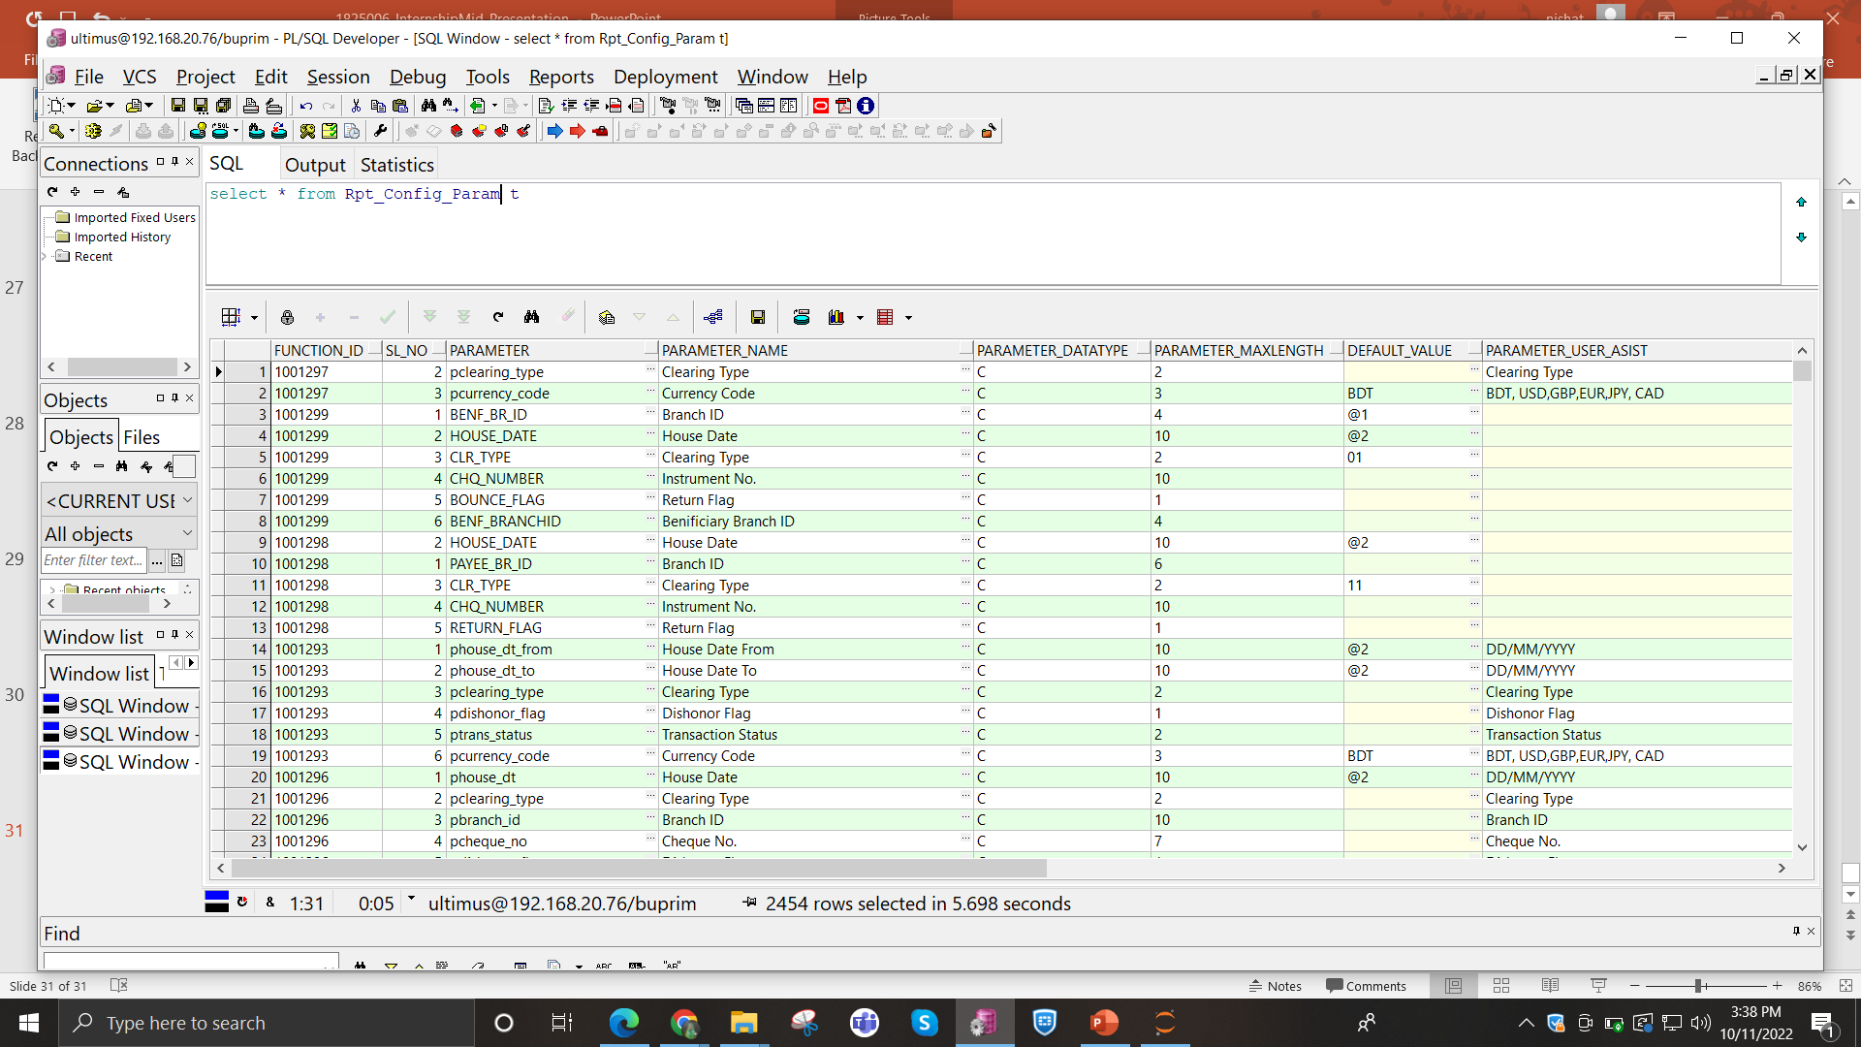

Figure 18: Database Table 3

**18**

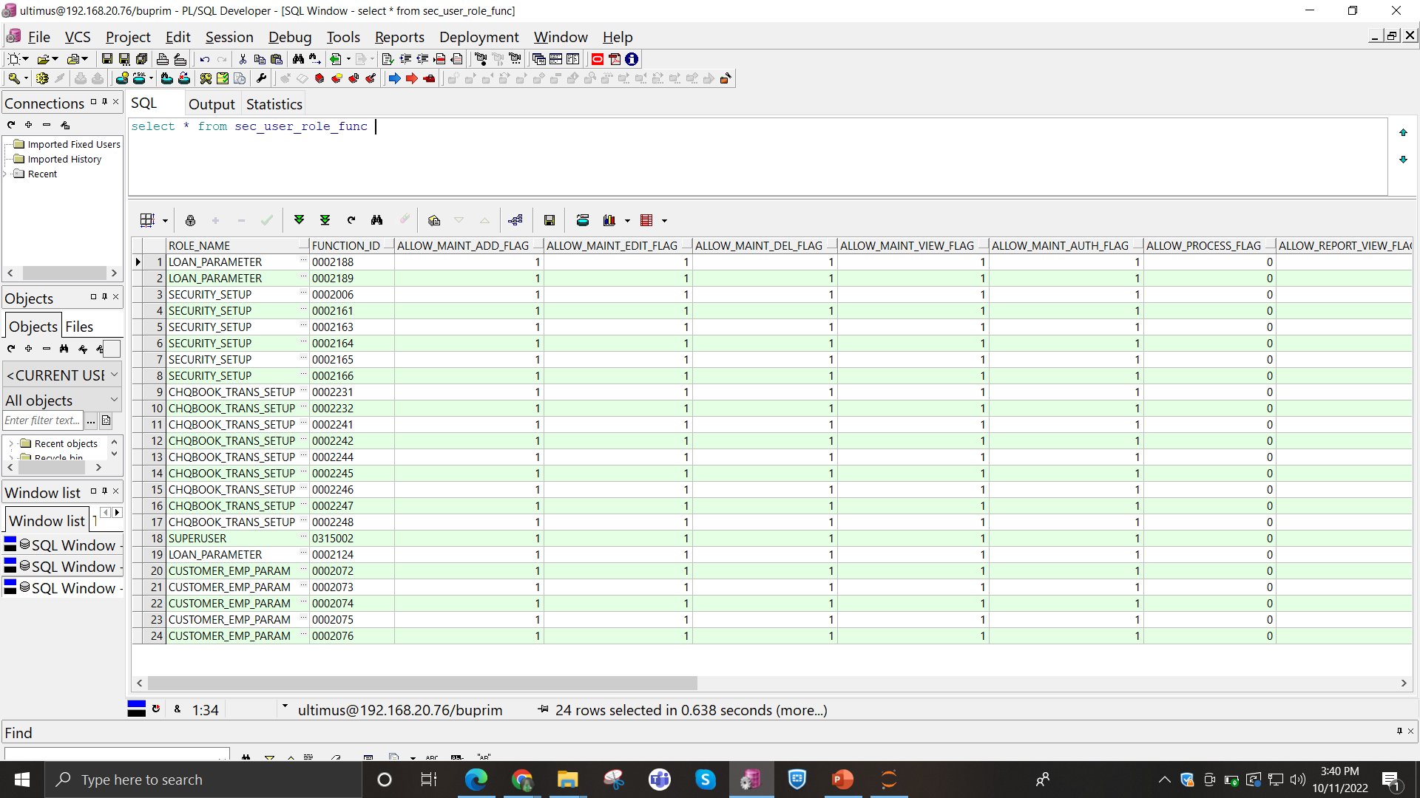

Figure 19: Database Table 4

### 3.2.5.4 Schema create in oracle

I created the Citizens Bank database schema with the help of my supervisor. All the data was provided to me, and I ran all the scripts successfully. However, running one particular script was a big challenge as it required many permissions, such as table permissions or creating synonyms for tables.

### 3.2.5.5 Live Deployment report

After completing the procedure and Crystal Report tasks, I deployed the report to the test environment. After successfully completing all tasks and testing in the test environment, I then deployed it to the bank's live test environment. Once it passed the UAT (User Acceptance Testing), I would deploy the report to the live database.

Sometimes, after the UAT, clients provided us with some observations. Following their requirements, I completed the necessary tasks and deployed the updated report in the live environment.

### 3.2.5.6 On demand services provide

Sometimes, clients faced issues, and when they required an immediate solution, I provided them with on-demand support. I assisted them through AnyDesk connection, with the help of supervisor or seniors.

**19**

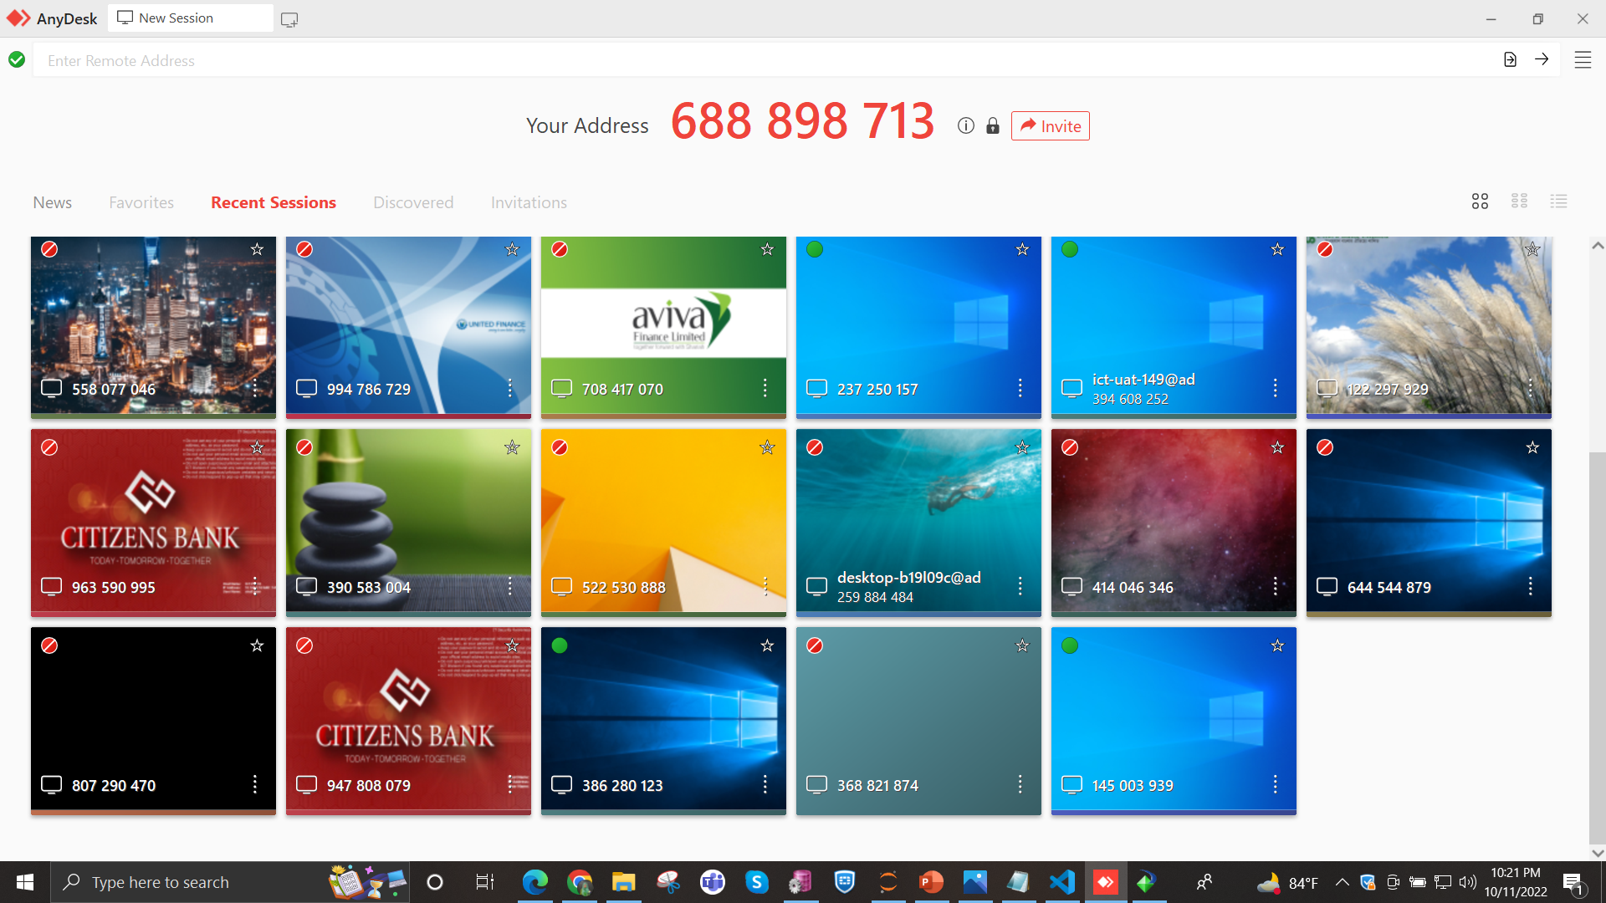

Figure 20: Client Anydesk

### 3.2.5.7 Client Visits

Recently, Leads' product BankUltimus was used in Probashi Kallyan Bank (PKB). I visited PKB with my seniors to address report issues. During the visit, we conducted meetings to discuss the existing report issues and collected new report requirements from them. We systematically solved each problem one by one.

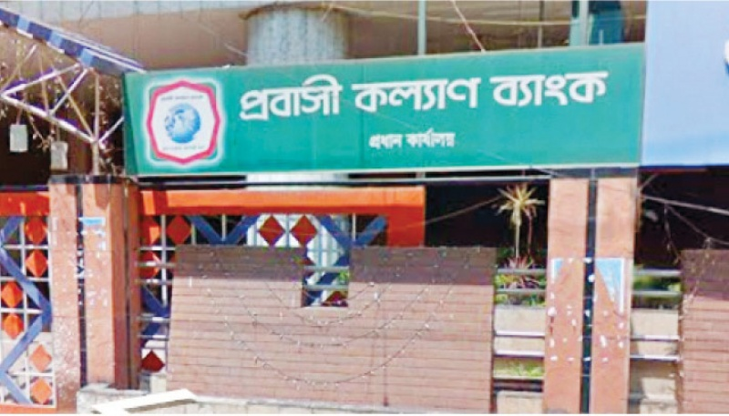

Figure 21: PKB bank

### 3.2.5.8 Attend Seminar or Meeting

I attended several seminars and weekly meetings to gain a better understanding of the banking domain. Every day, the manager also conducted sessions to introduce us to new technologies, and other team members did the same. These meetings and sessions are essential for us to continuously improve our technical skills.

**20**

### 3.2.5.9 Automated Beta Testing

The Report Team tests reports manually after they go live in any bank. For automated beta testing, I used Selenium automation tools.

### 3.2.5.10 Others Relevant Activities

My working experience with LEADS Corporation as an intern was delightful. The employees and the manager were incredibly supportive and helpful with any issues that arose. Besides handling the workload, I learned how to communicate effectively with different people and how to deal with clients. I received full support from my colleagues when facing any difficulties and gained valuable knowledge about the business.

As a programmer, I've gained significant experience here. While working, I encountered some challenges that were later solved by my senior colleagues, giving me valuable insights into problem-solving. Throughout my internship, I prepared myself to face any kind of challenge with integrity. As a result, I have honed my communication skills and developed expertise in my field. I truly believe that these experiences will be beneficial in my future job endeavors

* Work closely with the development team in an Agile SCRUM environment to refine and support the development, testing, and release of functionality.
* Manage the OTRS Ticket System for the Report team.
* Modify the database (table creation, insertion) and code.

## 3.2.6 Challenges

I was totally new to these technologies: Crystal Reports, PL/SQL, and the banking domain. That's why adopting these technologies was a big challenge for me.

### 3.2.6.1 Identified/Observed in the Organization

One of the greatest challenges was adjusting to the professional environment, where everyone is highly skilled, experienced, and works with a huge number of clients. Additionally, dealing with different kinds of clients in a professional manner and understanding their requirements was a big deal for me.

**21**

### 3.2.6.2 Academic Preparation

Gathering proper knowledge about banking was one of the biggest challenges for me because most of the clients of this organization are either banks or financial institutions. Without understanding the actual business and the BankUltimus system, it would never be possible to comprehend the code. Additionally, since I did not have any clear knowledge about writing stored procedures, learning this was also a challenge.

### 3.2.6.3 Personal/Professional Skills

Working under a huge organization and engaging in daily communication with a variety of people helped me overcome my social anxiety. The employees and the manager were incredibly supportive and helpful with any issues. I have been able to significantly improve and practice my professional skills during this internship. The manager personally supervised me and ensured that I was clear about every concept, which proved invaluable throughout this internship period.

**22**

# ***Chapter 4***

# ***Professional Growth***

## 4.1 Technologies and Tools I Learned

At Leads, I was a part of the Banking Solution Department, where I worked with both the Report Team and the Development Team. This experience allowed me to learn and use technologies that I had never encountered during my academic studies. I successfully adapted to the new work environment and also honed my skills in professional communication and other aspects.

### 4.1.1 Tools

For solving problem and learning I used these tools

* Visual studio code 2019
* PL/SQL database of oracle
* Crystal report 2011
* Client server
* Anydesk software
* Jupyter notebook

## 4.2 Technology

### 4.2.1 JavaScript Frameworks

To complete the test project, I learned the JavaScript language and its framework Vue.js, as well as the UI library of Vue.js called Vuetify.

### 4.2.2 Oracle database

Learn oracle database for create procedure, function, query etc in PL/SQL database of oracle.

### 4.2.3 Development Technique

During the internship period, I had the opportunity to pair with some of my seniors at different times. As I was new to certain technologies we were supposed to use, I always had a lot of questions. Therefore, I could clear my confusions while working with them and quickly learned the technologies. While working as a pair, we followed an agile programming technique, where one of us would type while the other assisted, provided ideas, and checked for mistakes. We would switch roles, with the other person giving instructions when the roles were reversed. I learned that this technique is known as pair programming. Every day, I attended the scrum meeting to discuss the day's work, and occasionally, when I had free time, the seniors assigned tasks to me. For one month, I took on the role of a scrum master and successfully fulfilled my responsibilities.

**23**

## 4.3 Professional Learning

### 4.3.1 No bullying and blaming

Software development is always a team effort, and with teamwork comes the possibility of misunderstandings. This holds true for Leads as well. However, I have never seen team leaders or project managers bullying people working under their supervision. Personally, I have made a lot of mistakes in the last six months, but our seniors handled those issues with great wisdom. I didn't blame anyone for any specific reason.

### 4.3.2 Complete task properly

There is no one giving orders like 'do this work' or 'do that work.' Instead, everyone is assigned to a particular task, and they have the freedom to approach it in their own way. During the scrum meetings, everyone shares their progress with others. All the projects are executed in this manner. As an intern, I had the opportunity to work at my own pace, allowing me to take more time to understand any issues related to the bank, etc.

### 4.3.3 Adaptability

Employers tend to hire experts who are able to adapt rapidly to changes in the working environment and embrace new challenges. During my internship, I learned a great deal about communication and how to adapt to new places and environments.

### 4.3.4 Punctuality

Time is truly important and must be respected by all. The daily SCRUM meeting started promptly at 9:15 in the morning, so I made sure to be punctual and maintained this habit consistently.

### 4.3.5 Self-confidence and Teamwork

Teamwork is truly important when working in a group. During my internship, I had the valuable experience of working with a team, which greatly helped me boost my knowledge and confidence.

## 4.4 Self-Assessment

### 4.4.1 Problem-Solving

The ability to discover creative solutions to problems is a pivotal skill for professionals in any career. Through my internship experience, I had the opportunity to enhance my thinking and problem-solving abilities. As an intern, I encountered various challenges and was encouraged to work hard and find solutions. Each new experience provided me with opportunities to acquire new skills and grow as both a well-rounded professional and individual.

**24**

### 4.4.2 Adaptability

Employers tend to hire experts who are able to rapidly alter to working environment changes and unused challenges. During an internship I have learnt much about communication and adapting with new place and environment.

### 4.4.3 Punctuality

I was very punctual in my work I provided me 4 out of 5 scale which is very good and I have needed to improve my punctuality.

### 4.4.4 Quality of work

Quality of work is 4 out of 5, Because our team work dependency is high we need to communicate with bank after passing UAT then report goes to live. That’s why maximum times our team work was not 100% accurate.

### 4.4.5 Overall Performance

My overall performance at Leads Corporation Limited is very good, with a rating of 4 out of 5. I would describe my performance as outstanding because, in the six months of my internship, I have earned the trust of my co-workers in the Report team. They consider me dependable and rely on me. The responsibilities assigned to a person can define their performance, and I have been entrusted with many responsibilities towards my project and my co-workers. This reflects my performance in the Banking Solution Department at Leads Corporation Limited.

**25**

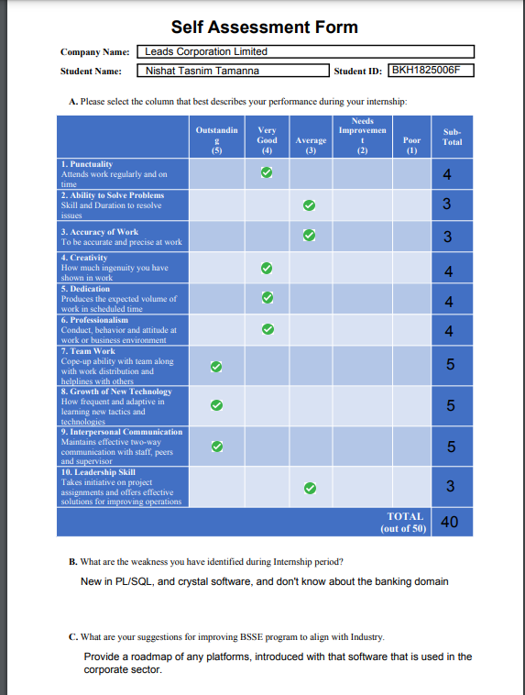

Figure 22: Self-Assessment

**26**

# ***Chapter 5***

# ***Conclusion***

The internship program played an essential role in shaping my career as a student. I am immensely grateful to have had the opportunity to work with LEADS as an intern. This experience has provided me with valuable knowledge and skills that will undoubtedly benefit me in the future. The skills I acquired during the internship will propel me closer to my dream job.

In my report, I have already highlighted my working experience and the skills I gained through the internship program. I will always cherish the hospitality of the company's employers, and I am committed to applying these skills in my future endeavors.

LEADS strives to be a beacon of excellence as an Information and Communication Technology company that our shareholders, clients, providers, partners, and society would cherish to be associated with. Our team works tirelessly to create value for all our stakeholders. With three distinct legal entities and unique product portfolios, LEADS creates opportunities for our partners to achieve their professional goals and helps our clients achieve their business objectives. We are dedicated to providing an environment where every team member feels valued, recognized, continuously learning, properly rewarded, and growing with the company.

Furthermore, this internship program is incredibly valuable for students as it helps them assimilate into the professional environment and gain insights into corporate life. This life lesson is invaluable for personal growth and future success. I am also grateful for the commendable way the university prepares students for corporate life.

**27**

# ***References***

1. <https://leads.com.bd/>
2. LEADS Facebook Page - www.facebook.com/leadsltd
3. LEADS LinkedIn Page - www.linkedin.com/company/leads-corporation-limited
4. JavaScript.com - <https://www.javascript.com>
5. Vue.js - The Progressive JavaScript Framework | Vue.js - https://vuejs.or

**28**

# ***Appendix***

## Elaborations

KYC- Know Your Customer

LC -Letter of Credit

TFN- Trade Finance

Dr- Debit

Cr - Credit

**29**